**Chapter 2**

**Vectors in Space**

**2.1 Vectors in the Plane**

**Section Exercises**

**For the following exercises, consider points   and  Determine the requested vectors and express each of them a. in component form and b. by using the standard unit vectors.**

1. 

Answer: a.  b. 

3. 

Answer: a.  b. 

5. 

Answer: a.  b. 

7. 

Answer: a.  b. 

9. The unit vector in the direction of 

Answer: a.  b. 

11. A vector  has initial point  and terminal point  Find the unit vector in the direction of  Express the answer in component form.

Answer: 

13. The vector  has initial point  and terminal point  that is on the axis and above the initial point. Find the coordinates of terminal point  such that the magnitude of the vector  is 

Answer: 

**For the following exercises, use the given vectors  and **

1. **Determine the vector sum  and express it in both the component form and by using the standard unit vectors.**
2. **Find the vector difference  and express it in both the component form and by using the standard unit vectors.**
3. **Verify that the vectors   and  and, respectively,   and  satisfy the triangle inequality.**
4. **Determine the vectors   and  Express the vectors in both the component form and by using standard unit vectors.**

15.  

Answer: a.   b.  c. Answers will vary; d.     

17. Let  be a standard-position vector with terminal point  Let  be a vector with initial point  and terminal point  Find the magnitude of vector 

Answer: 

19. Let  and  be two nonzero vectors that are nonequivalent. Consider the vectors  and  defined in terms of  and  Find the scalar  such that vectors  and  are equivalent.

Answer: 

21. Consider the vector  with components that depend on a real number . As the number  varies, the components of change as well, depending on the functions that define them.

1. Write the vectors  and  in component form.
2. Show that the magnitude  of vector  remains constant for any real number 
3. As  varies, show that the terminal point of vector  describes a circle centered at the origin of radius 

Answer: a.  b. Answers may vary; c. Answers may vary

23. Show that vectors  and  are equivalent for  and  where  is an integer.

Answer: This is a proof; therefore, no answer is provided.

**For the following exercises, find vector  with the given magnitude and in the same direction as vector **

25. 

Answer: 

27. 

Answer: 

**For the following exercises, find the component form of vector  given its magnitude and the angle the vector makes with the positive *x*-axis. Give exact answers when possible.**

29.  

Answer: 

31.  

Answer: 

33.  

Answer: 

**For the following exercises, vector  is given. Find the angle  that vector  makes with the positive direction of the *x*-axis, in a counter-clockwise direction.**

35. 

Answer: 

37. Let   and  be three nonzero vectors. If  then show there are two scalars,  and  such that 

Answer: This is a proof; therefore, no answer is provided.

39. Let  be a fixed point on the graph of the differential function  with a domain that is the set of real numbers.

1. Determine the real number  such that point  is situated on the line tangent to the graph of  at point 
2. Determine the unit vector  with initial point  and terminal point 

Answer: a.  b. 

41. Consider  and  two functions defined on the same set of real numbers  Let  and  be two vectors that describe the graphs of the functions, where  Show that if the graphs of the functions  and  do not intersect, then the vectors  and  are not equivalent.

43. Calculate the coordinates of point  such that  is a parallelogram, with   and 

Answer: 

45. The speed of an object is the magnitude of its related velocity vector. A football thrown by a quarterback has an initial speed of  mph and an angle of elevation of  Determine the velocity vector in mph and express it in component form. (Round to two decimal places.)

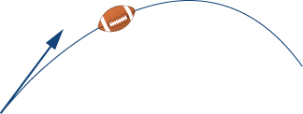

Answer: 

47. A bullet is fired with an initial velocity of  ft/sec at an angle of  with the horizontal. Find the horizontal and vertical components of the velocity vector of the bullet. (Round to two decimal places.)

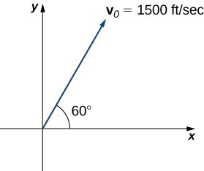

Answer: The horizontal and vertical components are  ft/sec and  ft/sec, respectively.

49. **[T]** Two forces, a horizontal force of  lb and another of  lb, act on the same object. The angle between these forces is  Find the magnitude and direction angle from the positive axis of the resultant force that acts on the object. (Round to two decimal places.)

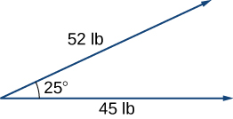

Answer: The magnitude of resultant force is  lb; the direction angle is 

51 **[T]** Three forces act on object. Two of the forces have the magnitudes  N and  N, and make angles and  respectively, with the positive axis. Find the magnitude and the direction angle from the positive axis of the third force such that the resultant force acting on the object is zero. (Round to two decimal places.)

Answer. The magnitude of the third vector is  N; the direction angle is 

53. **[T]** An airplane is flying in the direction of  east of north (also abbreviated as ) at a speed of  mph. A wind with speed  mph comes from the southwest at a bearing of  What are the ground speed and new direction of the airplane?

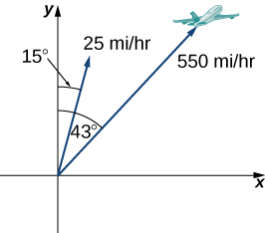

Answer: The new ground speed of the airplane is  mph; the new direction is 

55. **[T]** A -lb weight is hung by a cable so that the two portions of the cable make angles of  and  respectively, with the horizontal. Find the magnitudes of the forces of tension  and  in the cables if the resultant force acting on the object is zero. (Round to two decimal places.)

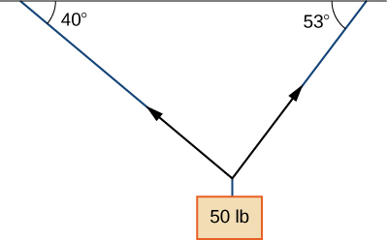

Answer:  

57. **[T]** A -lb boat is parked on a ramp that makes an angle of  with the horizontal. The boat’s weight vector points downward and is a sum of two vectors: a horizontal vector  that is parallel to the ramp and a vertical vector  that is perpendicular to the inclined surface. The magnitudes of vectors  and  are the horizontal and vertical component, respectively, of the boat’s weight vector. Find the magnitudes of  and . (Round to the nearest integer.)

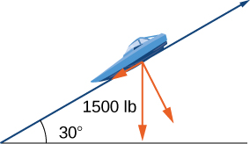

Answer:  lb,  lb

59. A guy-wire supports a pole that is  ft high. One end of the wire is attached to the top of the pole and the other end is anchored to the ground  ft from the base of the pole. Determine the horizontal and vertical components of the force of tension in the wire if its magnitude is  lb. (Round to the nearest integer.)

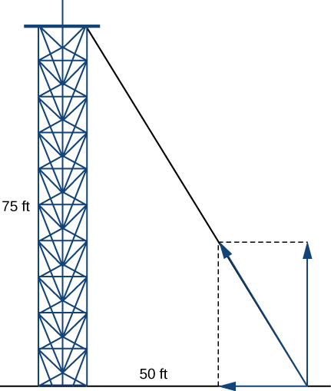

Answer: The two horizontal and vertical components of the force of tension are  lb and  lb, respectively.

This file is copyright 2016, Rice University. All Rights Reserved.